## Classification for maintenance strategy

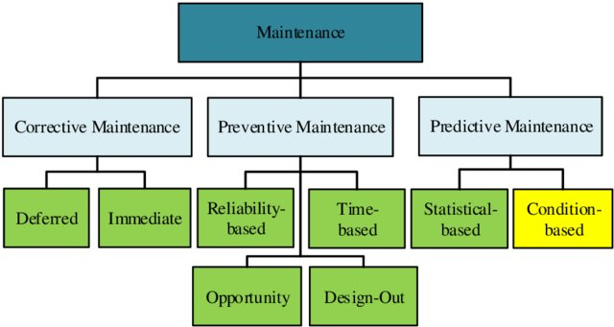

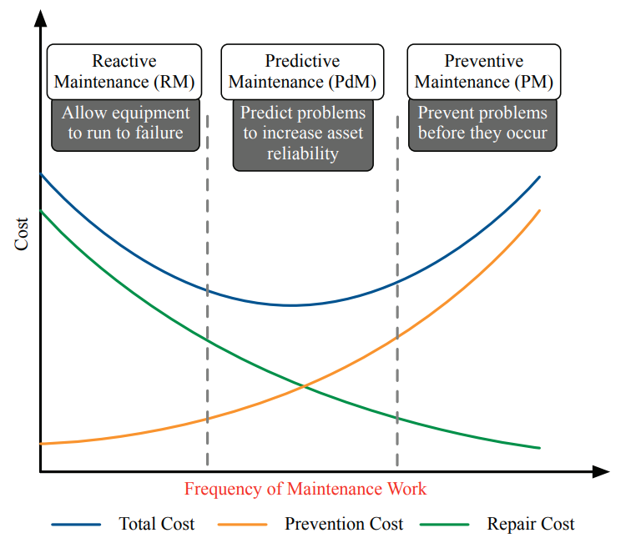

## Predictive maintenance definition

In [EN 13306:2010](http://irma-award.ir/wp-content/uploads/2017/08/BS-EN-13306-2010.pdf), prediction maintenance is defined as ‘condition based maintenance carried out following a forecast derived from repeated analysis or known characteristics and evaluation of the significant parameters of the degradation of the item”. The most important aspect of predictive maintenance is the use of methods and models for making a forecast for further condition development and remaining useful life.

## Predictive maintenance advantages and disadvantages:

Advantages:

* 1. Equipment is only shut down before imminent failure
  2. Total time spent for maintaining is reduced
  3. Cost is reduced
  4. Increase availability and reliability of the tools and machines
  5. Extend life of equipment and process

Disadvantages:

* 1. The cost for condition monitoring needed for predictive maintenance if often high.
  2. Technological challenges

Predictive maintenance maturity level

1. Level 1 Visual inspections: periodic physical inspections; conclusions are based solely on inspector’s expertise.
2. Level 2 Instrument inspections: periodic inspections; conclusions are based on a combination of inspector’s expertise and instrument read-outs.
3. Level 3 Real-time condition monitoring: continuous real-time monitoring of assets, with alerts given based on pre-established rules or critical levels.
4. Level 4 Predictive maintenance with Big Data Analytics: continuous real-time monitoring of assets, with alerts sent based on predictive techniques, such as regression analysis.

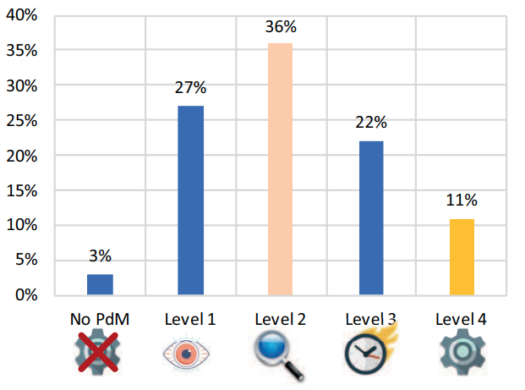

[Current predictive maintenance maturity level.](https://www.pwc.nl/nl/assets/documents/pwc-predictive-maintenance-4-0.pdf)

## Application of deep learning in predictive maintenance

Recently, deep learning has shown superior ability in feature learning, fault classification and fault prediction with multilayer nonlinear transformations. Auto-Encoder (AE), Convolutional Neural Network (CNN), Deep Belief Network (DBN), and other deep learning models are widely applied in the field of PdM

Advantages, limitations and typical applications of DL-based Approaches. Adopt from [Yongyi Ran et al.](https://arxiv.org/pdf/1912.07383.pdf)

|  |  |  |  |
| --- | --- | --- | --- |
| Networks | Advantages | Limitations | Typical applications |
| Autoencoder | • No prior data knowledge needed  • Can fuse multi-sensory data and compress data  • Easy to combine with classification or regression methods | •Needs a lot of data for pretraining  • Cannot determine what information is relevant  • Not so efficient in reconstructing compared to GANs | • Feature extraction  • Multi-sensory data fusion  • Fault diagnosis  • Degradation process estimation  • RUL prediction |
| CNN | • Outperforms ANN on many tasks (e.g., image recognition)  • Would be less complex and saves memory compared to the ANN  • Automatically detects the important features without any human supervision | • Hyperparameter tuning is nontrivial  • Easy to overfit  • High computational cost  • Needs a massive amount of training data | • Fault diagnosis  • Degradation process estimation  • RUL prediction  • Joint fault diagnosis and RUL prediction |
| RNN | • Models time sequential dependencies | • Gradient vanishing and exploding problems  • Cannot process very long sequences if using tanh or relu as an activation function | • Fault diagnosis  • RUL prediction  • Health indicator construction |
| DBN | • Has a layer-by-layer procedure for learning the top-down, generative weights • No requirement for labelled data when pretraining  • Robustness in classification | • High computational cost | • Fearture extraction  • Fault classification  • RUL prediction and early fault detection |
| GAN | • A good approach to train a classifiers in a semi-supervised way  • Does not introduce any deterministic bias compared to auto-encoders  • Can be used to address the class imbalance issue | • The training is unstable due to the requirement of a Nash equilibrium  • The original GAN is hard to learn to generate discrete data | • Class imbalance issue  • fault identification  • RUL prediction |
| Transfer Learning | • Saves training time  • Does not require a lot of data from the target task  • Can learn knowledge from simulations (e.g., digital-twin) | • Knowledge transfer is only possible when it is ’appropriate’  • Suffers from negative transfer | • Fault diagnosis: Representation adaptation, parameter transfer, adversarial based domain adaptation, digital-twin, AdaBN  • RUL prediction |
| DRL | • Can be used to solve very complex problems  • Maintains a balance between exploration and exploitation | • Needs a lot of data and a lot of computation  • Assumes the world is Markovian, which it is not  • Suffers from the curse of dimensionality  • Reward function design is difficult | • Operation and maintenance decision making  • Fault diagnosis  • Health indicator learning |

## 

## Implementation: deep learning as data-driven process for predictive maintenance

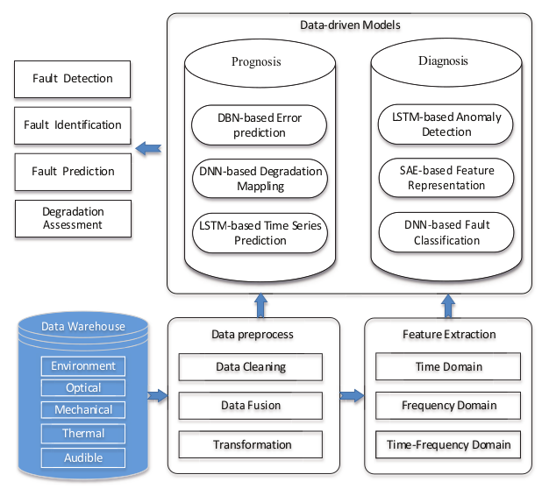

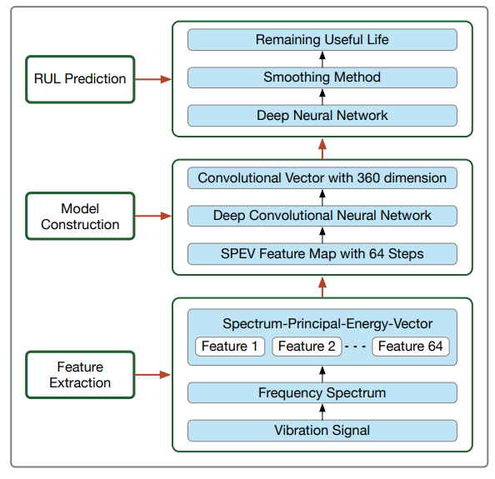

A framework of RUL prediction by applying CNN